
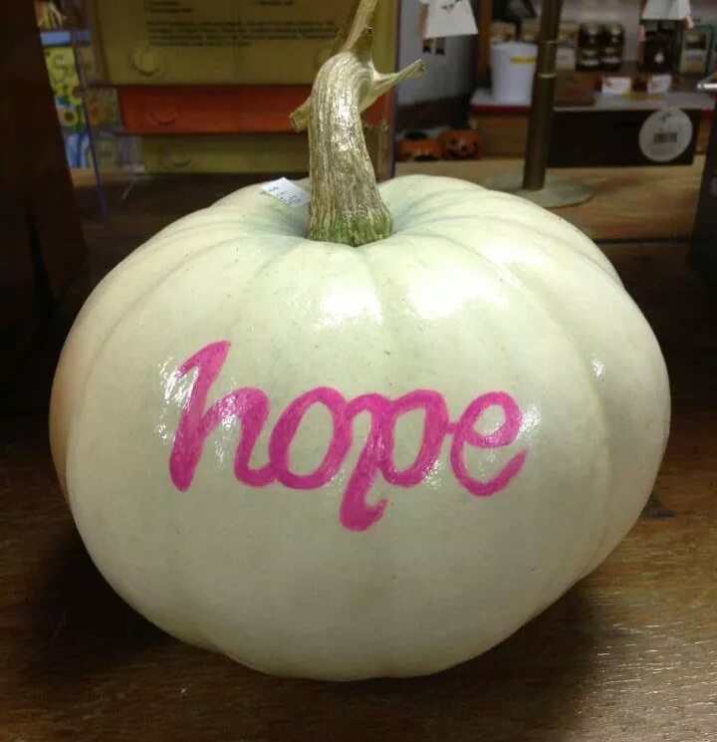
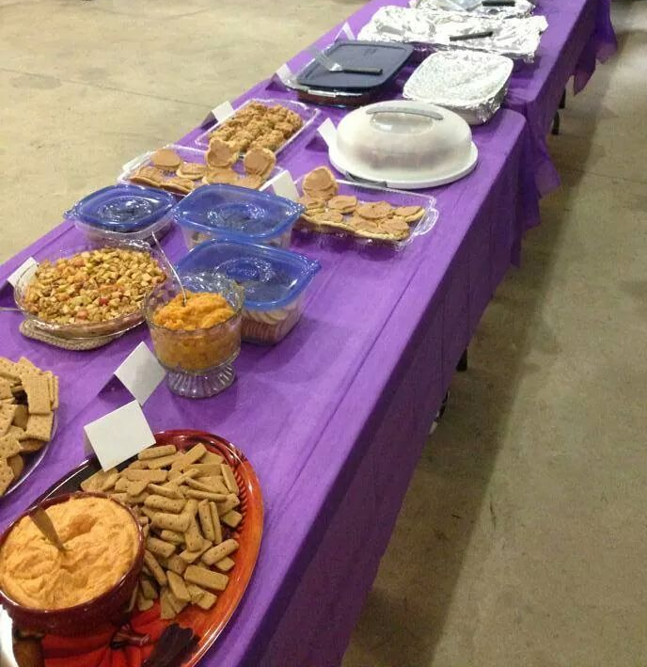
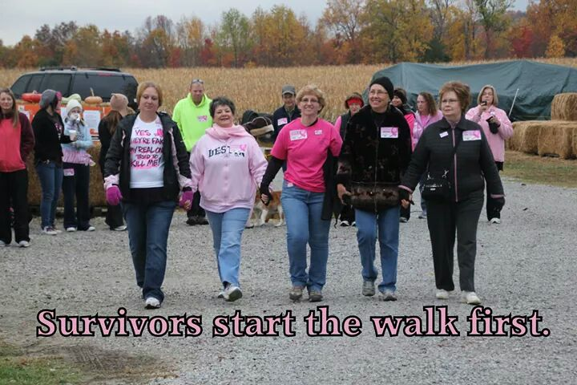

Harvest of Hope Walk
Benefits Relay For Life of Washington County
Saturday, October 17, 2015

Cornucopia Farm, 5444 N Rutherford Hollow Rd, Scottsburg, IN
(Just off Hwy. 56 halfway between Salem & Scottsburg)
Registration: 8:30 a.m. Event Start: 9:00 a.m.
Harvest Brunch immediately following ($5 suggested donation)
To print registration form to bring, go to http://harvestofhopewalk.org or http://www.cornucopiafarm.com . You can say you’re coming to the event on the Cornucopia Farm page on Facebook.
For more information, call Cornucopia Farm (812-752-6694) or Pam Hawes (812-620-1559).
Sponsored by Cornucopia Farm LLC and SHC Friends Relay For Life Team

